**Thermal diffusivity** **Week 6 05.11.2018**

**Planning**

**Aims**

* To gain an understanding of thermal diffusion in a material, and use Matlab to acquire and analyse a time-dependent signal
* To examine how a simple flash gun method may be used to determine the thermal properties of a material
* To write a script m-file that monitors a changing analog signal and uses it to determine the time-dependent response of a thermopile
* To acquire sufficient data to calculate the thermal diffusivity of stainless steel

**Theoretical Background:**

**Thermal Conductivity $k/ Wm^{-1}K^{-1}$**

A measure of a materials ability to conduct heat

**Thermal Diffusivity $α/m^{2}s^{-1}$**

$$α= \frac{k}{ρC}= \frac{heat conducted}{heat stored}$$

$ρ$ Is the materials density

$C$ Is the materials heat capacity (at constant pressure)

**Equation relating temperature and time**

$$\frac{T(L,t)}{T_{m}}=1+2\sum_{n=1}^{∞}{{-1}^{n}e^{-n^{2}π^{2}\frac{αt}{L^{2}}}}$$

where $T_{m}= \frac{Q}{CρL}=temp of back of plate$

Using Matlab’s symbolic maths tool for the first three terms

$$\frac{T(L,t)}{T_{m}}=1+2{(e}^{-39.4784x}-e^{-9.8696x}-e^{-88.8264x})$$

Plot $y= \frac{T(L,t)}{T_{m}}$ against $x= \frac{αt}{L^{2}}$

**Graph of theoretical temperature against time.**

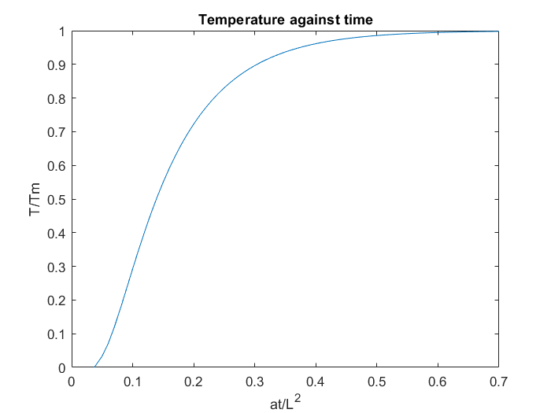

**Time taken for the temperature to rise half way to its maximum value**

$$t_{\frac{1}{2}}=0.139\frac{L^{2}}{α}$$

$t_{\frac{1}{2}}$ Can be estimated from a graph of temperature against time

X = 0.14 from the graph when y = 0.5 (half of maximum of 1)

$x= \frac{αt}{L^{2}}$

$t=x \frac{L^{2}}{α}$

$t_{\frac{1}{2}}=0.14\frac{L^{2}}{α}$

Which is the same as the equation above to 2d.p.

**Would expect a similar graph for task 2 for different plate thickness.**

**Thermopile Voltage to temperature**

$$V= T^{4}σε$$

$σ$ Stefan- Boltzmann constant

$ε$ Emissivity

For a small change in T:

$$V+∆V= {(T+∆T)}^{4}σε=T^{4}+4T^{3}∆T+6T^{2}∆T^{2}+4{∆T}^{3}T+ {∆T}^{4}$$

Powers of $∆T$ are insignificant if $∆T$ is small

$$∆V=4T^{3}∆T σε$$

$$\frac{∆V}{V}= 4\frac{∆T}{T}$$

$\frac{∆V}{V}$ is proportional to $\frac{∆T}{T}$ so it doesn’t matter that the heat detected by the sensor is proportional to $T^{4}$ as the temperature changes are small.

In the experiment it doesn’t matter that the exact calibration from voltage to temperature isn’t known exactly because we are only considering ratios of temperature (when temperature has halved) and a multiplicative calibration constant wouldn’t affect the ratio.

$$\frac{T_{1}}{T_{2}}=\frac{CT_{1}}{{CT}_{2}}$$

**How a thermopile works**

It is a series of thermocouples which have a voltage across them which is sensitive to a change in temperature. A temperature gradient will cause the charge carries in the thermocouple to move to lower temperature areas. The voltage reading gained from using a thermopile will be proportional to the temperature and so can be used to measure temperature.

**Equipment list:**

* Stainless steel sample plates of various thicknesses
* Base unit containing a phototransistor (time) and thermopile (voltage/temp)
* Power supply
* Flash-gun
* NiDaq interface and cables

**Method and Measurements**

**Task 2 Method**

* Debug and test software.
* Run the program and fire the flash gun (press the button labelled ‘test’).
* Estimate the value of the time taken for the temperature measurement to halve.
* Repeat for other plate thicknesses and print of the graphs.

**Task 2 Software Description**

* Needs to open two analog input channels to measure the temperature from the thermopile AI0 and the time of the flash from the phototransistor AI1.
* Only want times after the time on the phototransistor and temperatures taken after the time on the phototransistor.
* Need a labelled time(s) against temperature(V) plot to be able to estimate the time taken for temp to halve.

**Task 3 Software Description to calculate $t_{\frac{1}{2}}$**

* Find the time that corresponds to the time the voltage spikes due to the flash
* Only take readings of temperature after the spike
* Find half the maximum temp value
* find time that corresponds to that value
* plot time against thickness to find alpha
* calculate uncertainty in time

**Task 3 Expected Graph**

**Expected Values:**

Thermal Conductivity

<https://www.engineeringtoolbox.com/thermal-conductivity-metals-d_858.html>

Thermal Conductivity

<https://www.engineersedge.com/properties_of_metals.htm>

Thermal Conductivity

<http://www.goodfellow.com/E/Stainless-Steel-AISI-410.html>

Thermal Diffusivity(304A at 27C)

<https://www.engineersedge.com/heat_transfer/thermal_diffusivity_table_13953.htm>

**Expected Uncertainties**

Uncertainty in time = accuracy of thermopile

Uncertainty in thickness (measured using a micrometer) = smallest value measurable by the instrument = 0.01mm

**Questions**

Calibration of voltage to temperature

What form of data does the phototransistor give

Uncertainty in time to reach half max